Template for Evidence(s)
UI GreenMetric Questionnaire

University : ...
Country : ...
Web Address : …
SAMPLE
[7] Governance and Digitalization (GD)

[7.14] Compliance with the General Data Protection Regulation (GDPR) or Equivalent National Data Protection Regulations

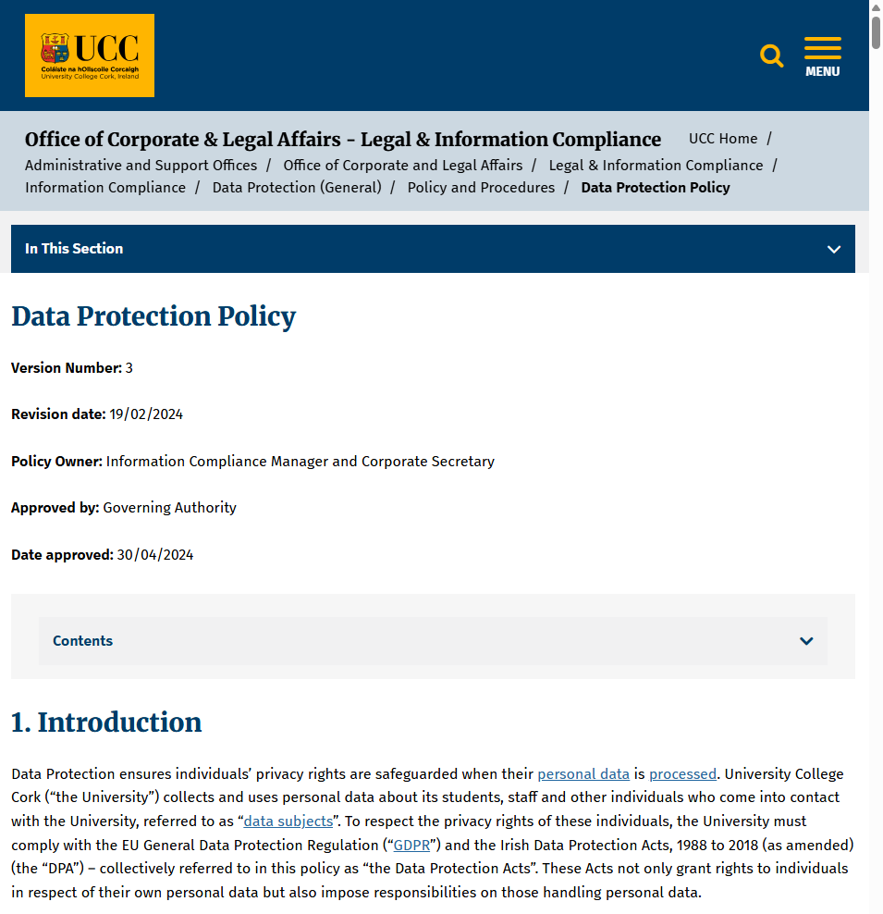
Data Protection Policy managed by UCC’s Office of Corporate & Legal Affairs

Description:
(Please provide concrete evidence such as institutional data protection policies, appointment of responsible units, consent mechanisms, procedures for data subject rights, security measures, or awareness programs demonstrating GDPR-aligned practices. For universities located outside the European Union, compliance may be demonstrated through alignment with equivalent national data protection regulations and institutional practices.)

University College Cork (UCC) demonstrates full compliance with the General Data Protection Regulation (GDPR) through a comprehensive, institution-wide data protection framework that is fully implemented, regularly audited, continuously improved, and transparently communicated to all stakeholders.

At the governance and policy level, UCC has adopted an official Data Protection Policy aligned with the EU GDPR and Irish Data Protection Acts. This policy is approved at institutional level, applies across all university units and digital systems, and clearly defines principles for lawful, fair, and transparent processing of personal data, including purpose limitation, data minimization, retention, and data security. The policy is publicly accessible on the university website to ensure transparency for students, staff, partners, and the public.

To ensure accountability and oversight, UCC has designated an Information Compliance Manager / Data Protection Officer (DPO) responsible for monitoring GDPR compliance, advising university units, managing risks, and serving as the primary contact point for data protection matters. Data protection responsibilities are embedded within institutional governance structures, with clear reporting lines and defined roles across academic and administrative units.

Additional evidence link (i.e., for videos, more images, or other files that are not included in this file):

1) Publicly Accessible Data Protection Policy
https://www.ucc.ie/en/ocla/legal-infocomp/informationcompliance/dataprotectiongeneral/policyandprocedures/dataprotection/

2) Data Protection Notices (including Staff Data Protection Notice)
- General Data Protection Notices – UCC: https://www.ucc.ie/en/ocla/legal-infocomp/informationcompliance/dataprotectiongeneral/dataprotectionnotices/
- Staff Data Protection Notice:
https://www.ucc.ie/en/ocla/legal-infocomp/informationcompliance/dataprotectiongeneral/dataprotectionnotices/staffdataprotectionnotice/

3) Designation of Data Protection Officer / Information Compliance Manager
Data Protection Officer details: https://www.ucc.ie/en/ocla/legal-infocomp/informationcompliance/dataprotectiongeneral/frequentlyaskedquestions/

4) Data Subject Rights & Consent Principles (in Policy)
As outlined in UCC’s Data Protection Policy under data subject rights and consent sections: https://www.ucc.ie/en/ocla/legal-infocomp/informationcompliance/dataprotectiongeneral/policyandprocedures/dataprotection/

5) Personal Data Security Breach Procedure (Example of Operational Procedure)
https://www.ucc.ie/en/media/support/ocla/compliance/gdpr/PersonalDataSecurityBreachManagementProceduresv2.0.pdf

